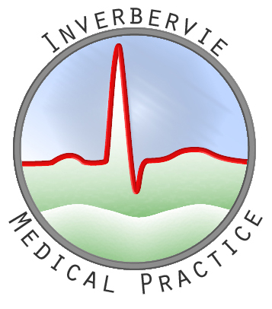

COVID-19 VACCINATIONS

Dear Patients,

We are writing to inform you that the COVID-19 vaccines for the over 80’s at Inverbervie Medical Practice will start on Saturday, 23rd January 2021. The practice has already started to contact this priority group.

We appreciate that most of the high risk group will not have access to Facebook, but if you have an elderly relative, please inform them about this message and what priority group they are in. Please do not telephone the surgery to ask when you will receive your COVID-19 vaccine as we do not have this information. We can only deal with the priority group when we are instructed to do so.

The priority groups are set by the Government as per the following table:

1. | Residents in a care home for older adults and their carers.
2. | All those 80 years of age and over.  Frontline Health & Social Care workers.
3. | All those 75 years of age and over.
4. | All those 70 years of age and over.  Clinically extremely vulnerable individuals*.
5. | All those 65 years of age and over.
6. | All individuals aged 16 years to 64 years with underlying health conditions which put them at higher risk of serious disease and mortality.
7. | All those 60 years of age and over.
8. | All those 55 years of age and over.
9. | All those 50 years of age and over.
* | Clinically extremely vulnerable individuals are described here. This advice on vaccination does not include pregnant women and those under the age of 16 years (see above).

Thank you.

Lorna Grubb
Practice Manager

